**Dark Skies Tekapo Web Application - Documentation**

*By Rory Turnbull 7/12/21*

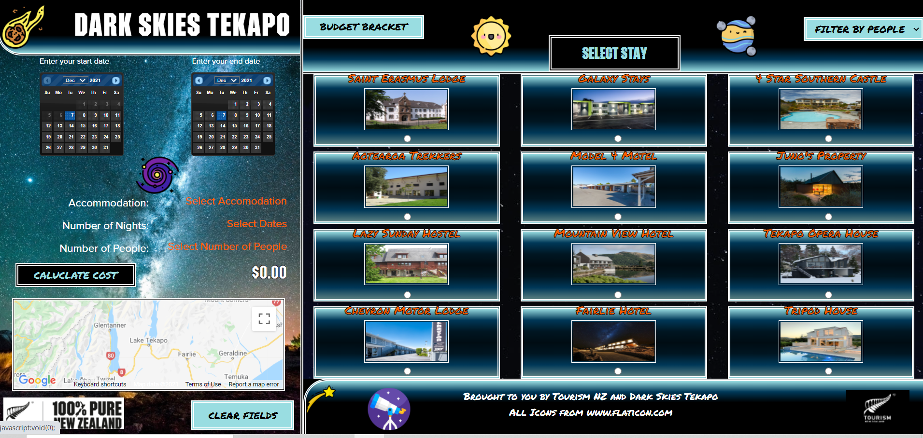

(Screenshot of completed web application).

**Index**

* Timeline - Page 2
* Hypothesis/Pitch - Page 2
* Competitor Analysis - Page 5
* Personas - Page 10
* Survey Documentation- Page 12
* Low Fi and Hi Fi Mockups - Page 17
* Flowchart - Page 18
* UMI Chart- Page 18
* Conclusion/Justifications- Page 19
* (Coding Style Guide, Site Readme, Moodboard and Reference Guide are separate documents included in Repository)

**Timeline**

***Start Project: Thursday 4th November***

* Hypothesis
* Moodboard
* Competitor Analysis
* Target Audience
* Personas
* Survey

***Milestone One: Tuesday 9th November***

* Low Fi Mockup
* Focus Group
* Hi Fi mockup
* Re-evaluate hypothesis + milestones

***Milestone Two: Tuesday 16 November***

* Coding mockup
* Start Coding
* Debugging
* User Testing

***Milestone Three: Tuesday 23 November***

* Finish Coding
* Final Debug
* Final re-evaluation
* Last touches to coding

***Milestone Four: Sunday 5th December***

* Wrapup writeup
* Presentation
* Hand In

***Milestone Five: Tuesday 7 December***

**https://trello.com/b/4rHiP9LN/summative-coding**

**Hypothesis/Pitch**

Tourism NZ is an umbrella company that is involved in all aspects of tourism in New Zealand, foreign and domestic. Tourism NZ is seeking a new booking system for a small company that it is associated with. The company wants a one page application for customers to use to browse the accommodations they offer and make bookings on the one of their choice.

I will create a single page application for Tourism New Zealand based around sorting, filtering and storing information using Javascript with tourist accommodation. This web application will be an intuitive, easy to use system for tourist users to input their details (number of people, dates and times, selection from different accommodation options and menu/food options). This web application will validate as to the input from the above criteria and tell the user when validation cannot be completed for a reason like: the end date is before the start date or the user has selected a date that does not fit with the timetable schedule of the particular accommodation. The user will also be notified about the total costs compiled from their accommodation choice and amount of days spent there and will be able to choose whether or not they want onsite food from a menu. Contact information for Tourism NZ and the accommodation sites, such as addresses, will be included. The application will take up one page, with a possible additional page for contact details and terms and conditions (alternatively these will appear in the footer or a pop up window). I will endeavor to keep the website as accessible and readable as possible, and the application as easy to use as possible - including te reo language and information relevant to tangata whenua.

Dark Skies Tours, based in Tekapo, NZ. These will be based around dark sky tourism, which is a growing sector of the tourist economy worldwide for locations with minimal light pollution where the night sky can be clearly viewed. The accommodation will be located in and around Tekapo, offering a variety of accommodation for each budget level (hostel, hotel, motel and house) with a variety of prices which will be filtered through using either a toggle that can be dragged or selecting radio buttons by the user.

The visual side of the web application will utilise a black background, with white text and icons and a light, warm blue as a spot colour. Links and button borders will stand out in yellow to draw the eye. These colours are drawn from the Tourism NZ style guide, butthe blue has been changed slightly to suit the application theme, as the initial blue was more oceanic whilst my new custom blue has a more cosmic, spacey feel. Tourism NZ also specifies the fonts that will be used. Proxima Nova is from their commercial website and will be used for body text, whilst Pakati Pure (a custom font) will be used in titles and links associated with Tourism NZ. I will be using another custom font that replicates a permanent marker effect on titles and headers specific to the Dark Skies Tours brand and in the logo for this brand. Tourism NZ logos, catchphrases and links will be used prominently as specified by Tourism NZ.

I will utilise high quality night sky shots from the Tekapo area, available online, as background for containers. Accommodations will include night shots, as well as shots at different seasons to reinforce that these activities can be done year round- Tekapo is near the winter attractions in the South Island like Mount Cook. Google maps will appear at the bottom of pop up card modals, as well as a map showing Tekapo in general as part of the placeholder. The placeholder will be a slideshow of night sky shots and accommodation shots that scroll past horizontally when no accommodation card has been selected by the user. I plan to make use of space styled free icons, such as stars, planets and meteors on button links, personal branding logos and bullet point lists to give the impression of glow stickers in a kids room. These will utilise hover features to mimic a glow.

The functional part of the website (the inputs and buttons the user manipulates) will be included in a sizable side menu with the options selected by the results appearing to the side covering much of the screen. These options can be modulated by an array of options buttons above, additional information and clearing buttons will be on the footer to the bottom. When the web application has no selections made by the user, a slideshow of outside shots of the accommodation will pass by - similar to the slideshow image on the homepage of Tourism NZ website. A mobile version will reduce the side menu to a sliver, which can be clicked on and expanded by the user to manipulate the inputs, with the main part of the screen filled by accommodation information. The accommodation info will utilise a modal card system, essentially being a very large card that will be appended into this section.

Before coding starts, I will need to decide whether this web application will primarily use grid layout or flexbox layout. Finally, I have completed a milestone structure to make sure that I complete this project on time for Tourism NZ.

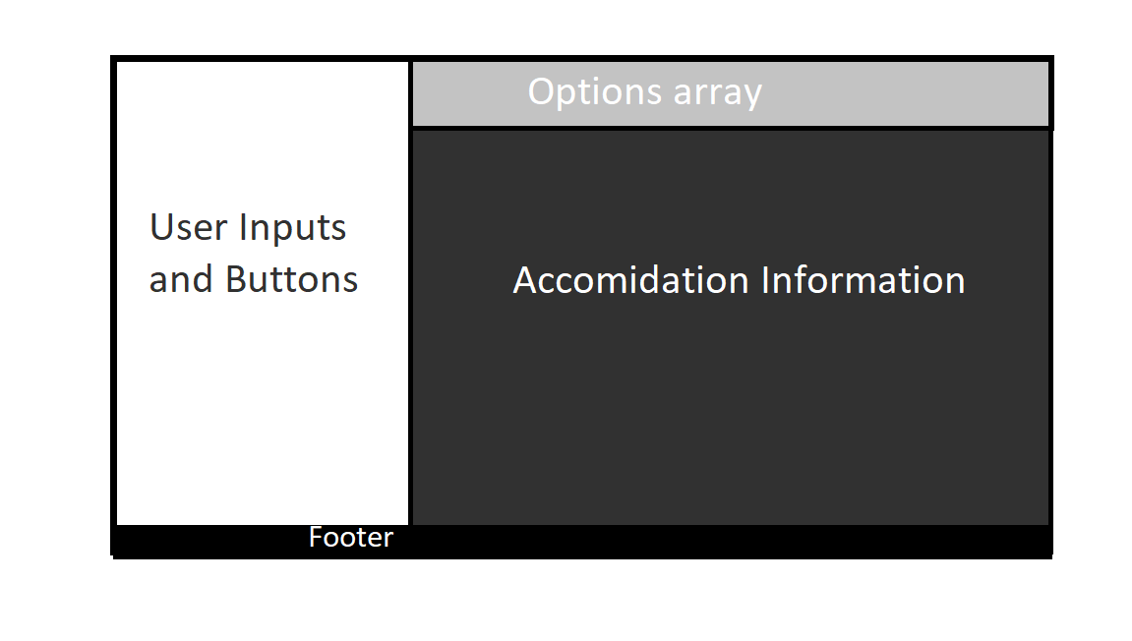

Table above shows the basic plan for how the page will be spaced out in desktop orientation.

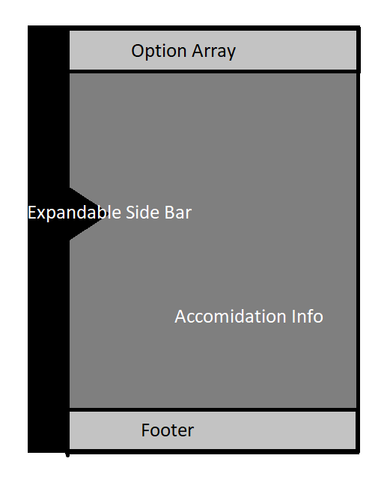

Table above shows the basic plan for how the page will be spaced out in mobile orientation.

**Competitor Analysis**

<https://www.tourismnewzealand.com/>

<https://woodlandsofmarburg.com/the-haunted-mansion/>

<https://visitatchison.com/product/sallie-house-overnight-stay>

<https://chillingham-castle.com/>

<https://www.booking.com/>

**Tourism NZ**

| Strengths   * Nice monochromatic colour scheme that reflects the black, white and silver colours of the silver fern and NZ’s sport teams. * Good use of negative space on the sides, centering the website but not making it look too sparse. * Simple, accessible top nav bar with drop down menus to organize links. * Slideshow of NZ nature shots to promote NZ’s strongest tourism attribute, the natural world. * Search function easily accessible but not taking over the screen on the top right. * Nice use of the silver fern logo, helps identify the site as uniquely Kiwi. On brand. | Weaknesses   * Annoying call to action when loading the website asking if you are a corporate. * Spelling mistakes in the footer - looks unprofessional. * Links to tourist resources in footer and thin bar above the nav are too hard to read and not highly visible. |
| --- | --- |
| Opportunities   * Needs more use of te reo and links to maori tourism to promote indigenous culture. * Could have links to accommodation and local attractions rather than research information at the bottom of the home page. * Use of a spot colour, border or hover function to draw attention to important features. * Use of covid-19 health information. | Threats   * Asking users if they are corporates as the first thing they see risks putting off general users and is abrasive. * A bit too formal, could have a more casual vibe to attract younger tourists like backpackers. * No covid 19 information or information on when NZ is opening up for international travel, or information on travel within the different covid levels in NZ. Makes website somewhat irrelevant in respect to current events. |

**The Haunted Mansion**

| Strengths   * Nice gloomy aesthetics that reinforce the ‘haunted’ brand. * Very unique logo. * Social media links are easy to see and access on nav bar. * Nav bar a good example of a dark coloured link bar with white text. * Good interior and night shots further down on the home page. * Accessible button low on the screen to return the user to the top of page, useful on long pages. * Menu on home page, easy to find. * Links on the nav bar for different uses of the venue, from accommodation to weddings to an onsite restaurant. | Weaknesses   * Takes far too long to load. * Center space could make use of photographs of the hotel rather than a very large version of the logo. * Much of the information, like terms and conditions, could be on their own pages or pop up links not the main page. Makes it too long and cluttered. * Footer is very plain and obviously an afterthought. |
| --- | --- |
| Opportunities   * “Book Now” button on the right edge could be displayed in a better, more prominent place as a call to action. * Put night shots of the hotel further up the homepage, with stormy day time shots to reinforce the atmosphere. * Format the menu items more appealingly, with images on a pop up window. * Accommodation information could be made more prominent. | Threats   * The heavy use of animations and coding that leads to a slow load time puts off potential users. * Too much information on the home page may make users feel overwhelmed or find it too hard to get the info they want. |

**Visit Atchison**

| Strengths   * Good simple design for a smaller website. * Interesting house background story. * Simple, easily accessible form for working out costs, amount of guests and stay duration. | Weaknesses   * References that the hotel was on TV but not what it was on. * Needs better, creepier photos in the homepage gallery. * Too much white negative space. * Search button when clicked takes up the whole screen, obscuring the rest of the website. |
| --- | --- |
| Opportunities   * The links to the hotel appearing on television and why could be reinforced for users to draw interest. * Background story could be displayed more prominently with its alleged hauntings to draw horror tourists. * Lacks calls to action. | Threats   * Having a ‘naughy list; of what guests should not do very prominently on the home page may really put off guests. * Not immediately clear that the website provides accommodation in two different locations, one of historical influence, the other the ‘haunted house.’ Confusing. |

**Booking.Com**

| Strengths   * Very readable, very accessible simple layout. * Effective use of off whites rather than standard whites which can look cold. * Very easy to use search bar, with calendar and price calculator contained within a single horizontal container. * Localised NZ tourist destinations. * Links to other travel necessities, such as taxis, car rentals and attractions. | Weaknesses   * Several pictures on the main page would not load, others took time to load. Graphics heavy websites tend to do this. * Very large footer with lots of links, this information would be better contained on its own page or on a popup or dropdown menu. |
| --- | --- |
| Opportunities   * Could ask users to bring across their information from another platform like Facebook, Twitter or Google - a lot less abrasive than getting personal information without being asked to. * Could be made more personable and less generic in its use of colours, icons and graphics. * Homepage is too vertical- could be organised in a more horizontal manner as lots of scrolling is not user friendly. | Threats   * Already knew my name and email on the very first detail- and I have no account. This kind of information skimming from cookies or other websites without being asked risks making users think its untrustworthy. * Giving users ‘levels’ like a computer game is strange and off putting. |

Writeup on SWOT:

After looking through a variety of websites ,both large tourist booking sites like bookking.com and smaller, more niche sites running a small number or a single accommodation venue, I have come to some conclusions about how to make my application for Tourism NZ:

* I wish to create a website that uses a lot of pictures but must work within the code to make sure this does not lead to lengthy loading times, as this is very off putting and can lead to users going to an alternative website. The Haunted MAnsion is a good example of an overly long load time.
* The text, nav bars and forms on the website should be intuitive, easy to read and located in easily accessible places. I am looking to avoid a too vertically structured approach like booking.com, instead having all the information visible without scrolling is the ultimate goal.
* Being too commercial in overall style, like booking.com and Tourism NZ can be quite off putting for customers, a more informal, casual style - but at the same time still looking reputable- will be key to my design parameters.
* I do not wish for any pop ups to come up without the user clicking on them, this can come off as overly familiar and pushy (both Tourism NZ and booking.com fail in this regard). I would rather draw the users eye to key segments of the application with design features.
* I want to have a map to Tekapo clearly displayed without the user having to click options, as all the accommodation is there and I want it to be visible (once accommodation options are selected, the map will also clearly mark their location.) In a similar vein, I wish for the date calendar, number of people options and accommodation options to also be automatically displayed so the user does not have to go looking. All of the above websites except for Visit Achison failed in this regard and were over complex, showing too many options at once.
* The calendar input, cost calculator and number of peoples options should be very prominent and contained within the same box - but be rather lightweight in design also- like the booking.com example.

**Personas**

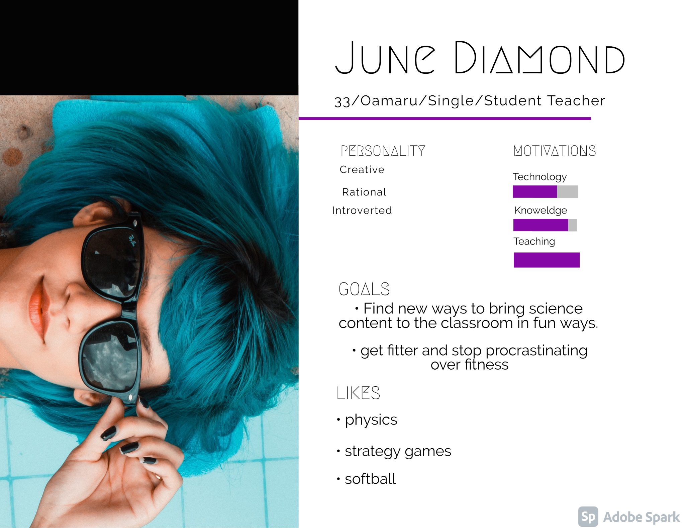

June Diamond is a prototypical example of a single traveler staying at Dark Skies Tekapo.

She is in her early 30s and has a moderate income stream, she would like to take a short holiday (2-4 days) with a cheap accommodation provider (she would stay in a hostel, paying nightly, if she used the web application.)

She is training to be a teacher by trade and is always looking out for new ways to get her primary school students interested in science. She would use this trip as an opportunity to explore ways of bringing children's natural interest in space into the classroom. She is also interested in learning te reo names for stars and planets, as well as Maori traditional knowledge and legends of the night sky.

As she lives in the South Island, Tekapo is a convenient place for her to get to. Having onboard menus will also help with her modest budget. She can also travel during the day to nearby nature walks to improve her fitness.

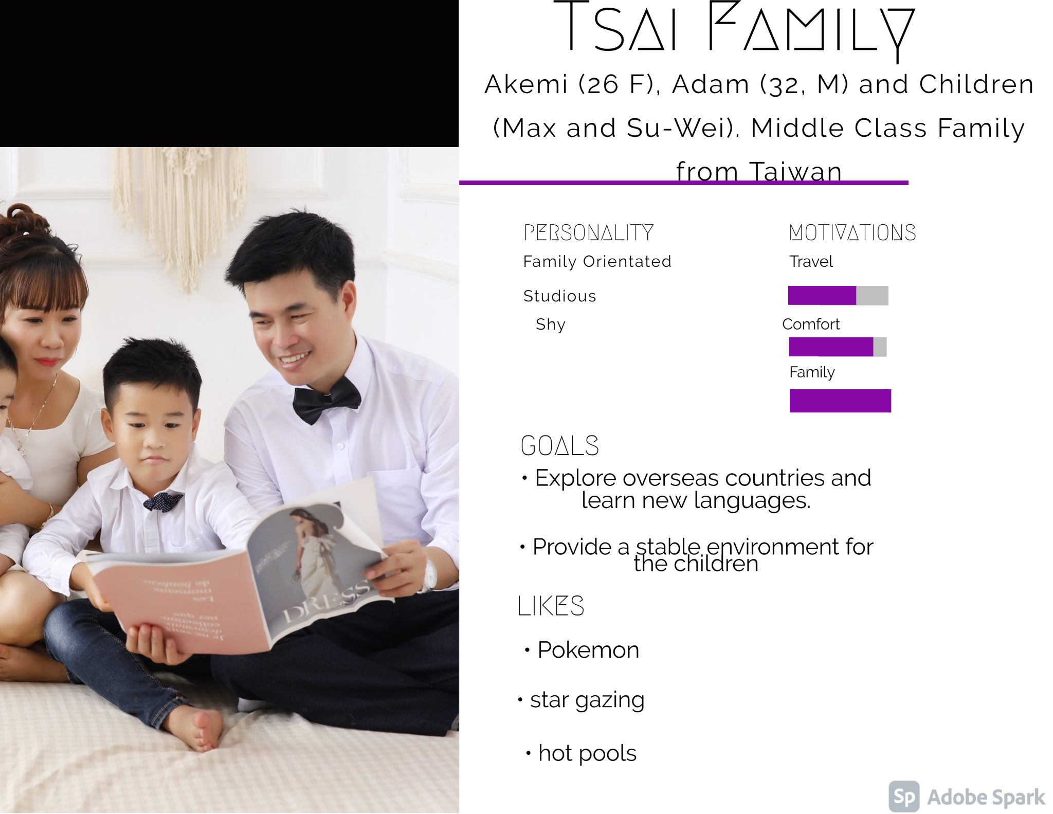

The Tsai family are from Taiwan. They consist of parents Akemi and Adam, who both work as graphic designers. Their children, Max and Su-Wei, are twins and are 4 years old.

The Tsaia family want to make their first trip overseas since the kids were born. They used to love travelling when younger and are multilingual so have no trouble in an English dominant environment. They also enjoy learning about other cultures so New Zealand was a perfect destination.

They chose to come to Dark Skies Tekapo as it is family friendly and they like to make outings educational for the children. Adam is an amatuer astronomer and he wants to foster this interest in the children.

They are an upper middle class family and have a relatively high budget, so they would most likely rent a house for a week, and use it as a base to explore the central South Island. Getting meals at the accommodation is not a priority for them, as they are most likely to eat out - but getting breakfast is convenient for them in the morning as they tend to the children.

**Survey Documentation**

I put out a preliminary survey for my web ap;plication for Tourism NZ, asking some general questions about use of tourism booking applications and trends.

Here is a breakdown of my results (I had 7 responders, this was a bit disappointing, but with the workload I had on the rest of the project I did not have time to chase people to do the survey, I plan on doing a second survey just before I start coding on my hi fi mockups).

**Question breakdown:**

How does the use of online booking services influence your holiday making choices?

* It's essential
* Greatly as this is where I go to peruse and choose holiday destination and all details.
* Little to none.
* Good quality websites and apps give me more faith in the quality of other aspects of a service.
* I like to see pictures inside and out before making decisions.
* Yes, greatly.
* No, as my partner usually does this.

**Writeup: This question was asked as a light opener to introduce the answerers to the subject at hand, and get a general overview of how people use and are influenced by online booking services. Only one respondent here was not influenced by online booking services, several were heavily influenced.**

Do images play a major role in these decisions?

* Yes, but not always
* Yes as I like to check that the environment will be attractive
* Of locations/ scenery yes. Otherwise no
* Yes
* Yes inside and out
* I prefer pics with text too.

**Writeup: this question was asked as I planned on having an image heavy website. The answers here were vague, but everyone wanted at least some picture usage.**

How do you find the experience of using website forms and inputs (such as calendars for booking dates and price calculators)? Are there any aspects to doing these activities that you find difficult?

* No they are useful
* Some websites better than others. I like clear calendars that show availability and costs. Also show clear cancellation options and no hidden costs.
* The required sequence if often not stated, causing refreshing the page to be the only way to fix it
* Sometimes they can be poorly formatted, and can be frustrating to use because of this and other reasons. Generally I find these simple to use though.
* I like websites that use New Zealand.British calendars, not American calendars (month first) as they are confusing to me.
* Usually are poorly made, with no clear or cancel button.
* Sometimes they are too familiar, and automatically log me in.

**Writeup: This was an essential question, but I did not know how to phrase it to get more specific answers from a group of users who had varying technological skills. Regardless, some of the answers will inform me on how to go forward, such as using a dd - mm - yy format instead of an mm - dd - yy format. Having the cost calculators and calendars very clear and simple is of very high priority, confirmed by this survey, as well as having clear cancel and reset buttons. Users find these functions useful when making travel plans, but they can be confusing or frustrating when not clearly set out or put in a strange place- or separated into chunks across a web application. Thus the final sidebar for my product will have all these functions accessible placed in one location, with a minimum of text or labels - using intuitive and simple design to inform users of how to make choices. Priority will also be given to formatting of these inputs to avoid confusion.**

Visit the website https://www.tourismnewzealand.com/. What do you think of this website's appearance and functionality? Good things? Bad Things?

* The pop up screen that comes up over the site upon entry is very annoying and should be integrated into the webpage
* I quite liked as the menu has a choice of what type of holiday you looking for ie hiking and South or North Island. Lots of options and information. Bad things didn't really come up with any
* Minimalist and not too eye grabbing
* It seems to be formatted clearly and effectively. All of the information is easy to access. If I had one complaint it would be that the home page is uninteresting, but it is not unattractive.
* Pop up kept coming up saying the website was commercial.
* Tries too hard to look like an All Black affiliated website with all the logos. NZ is about more than this.
* Looks geared towards overseas tourism, quite minimalist.

**In retrospect this question should not have been in the survey as it possibly confuses responders into thinking my survey is about the Tourism NZ page in particular. It does not really serve much purpose beyond getting some aesthetic feedback on the website, as I will be incorporating some of their styling into my application to make it clear it is being made for Tourism NZ. One thing that stood out in these answers is that people found the page too minimalist, and quite plain. Popups on the webpage that come up without clicking on anything will also be avoided, as several users noted that they found this distasteful. I want to reference Tourism NZ to make the association clear, through use of logos and fonts, but also make the product a separate but related entity, and not fall down the pitfall of having the application too plain and minimal - or a carbon copy of the Tourism NZ page.**

How many people do you take on your average holiday within NZ?

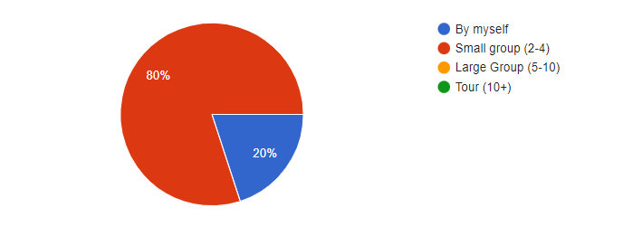

**This question was put in to get a demographic idea around if my “number of peoples” options were realistic .Ultimately I did not get enough answers to get a good answer on this, the only clear result is that most NZ holiday makers travel in small groups.**

Is it important to have an onboard food service with menus at your accommodation? If so, do you have any preferences around this?

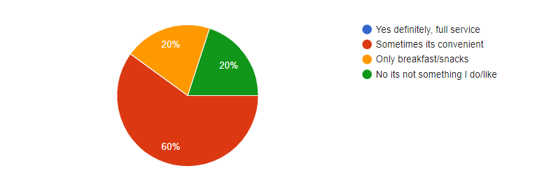

**This question was posed so I could start planning the menu options for the website, which the brief wanted included but had no further guidance on what this aspect would consist of. Looking at a breakdown of the results, it was clear that most users would only want this service sometimes- with some only wanting breakfast and/or snacks. Some users also wanted no meal options, so I will include a breakfast and a “no meals” option in my pop up selection.**

Does going on a holiday to Tekapo to view the stars in a dark sky (no light pollution) area sound like a good idea for a holiday to you?

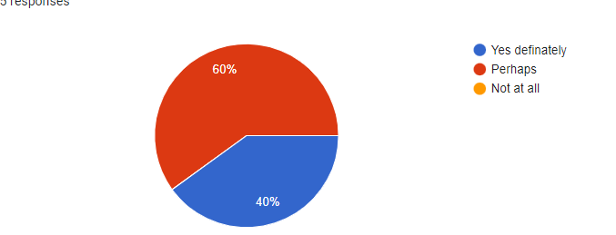

**This simple closing question was asked just to confirm that my idea for Tourism NZ of making an application to book accommodation in the developing dark skies tourism sector was a valid commercial venture. The survey proved this as no one answered in the negative, just under half answered in the highly positive. From this I draw the conclusion that many would do this as a side activity, along with other nearby activities such as easy access to mountains and nature walks, lake activities and visiting places of historic interest. All of these things are available in the Lake Tekapo area, and to expand the amount of tourists using the app I will be referencing these other activities in the area.**

**Some problems that have come up in my design include that I am unsure how the search function is going to work, as only one accommodation card is ever visible. To get around this, I am going to have a popup window with search results next to radial inputs, when one is selected, that card is inserted in the card space. Menus will also be on a popup, with a selection of menu types (A, B, C and D). Some menu types will only be available in some accommodation types. A no-menu option can alo be clicked, which reduces overall price by 10% (inclusion of this will be time dependent).**

**Another problem is how to integrate the accommodation option (each accommodation type will have three options) with the options on the side bar (number of people, number of nights etc.)**

**Low FI and Hi Fi**

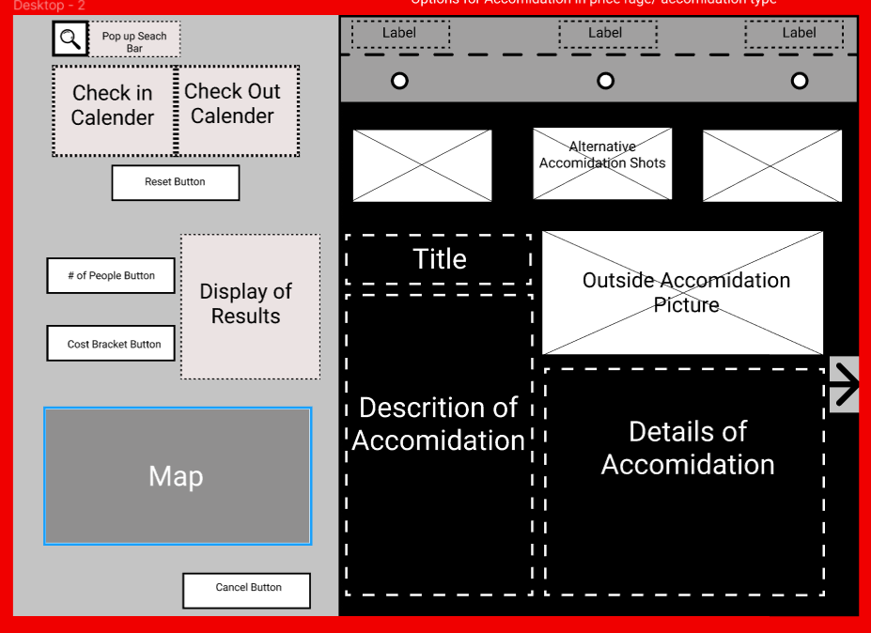

(example low fi)

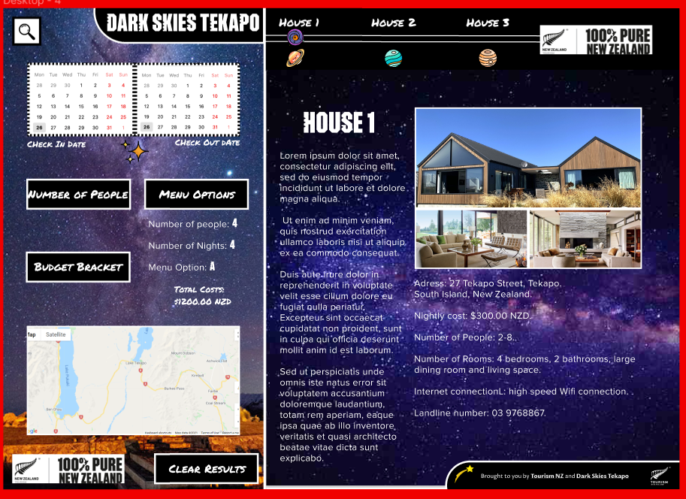

(example hi fi)

**https://www.figma.com/file/2IbT95qOkR2AsrMIBYZQs4/Tekapo-lowfi?node-id=0%3A1**

FInally some simple A/B testing of my low fi designs set the outcome for my hi fi design of the web application. I had two options for the input side bar and two options for the main display section where the accommodation cards would be placed. The sidebar from the second desktop low fi (B) was found to be the most popular (8/10 votes), and the main section of the first desktop low fi (A) was also selected (6/10 votes). These were also my own favourite options.

A similar process was done for the cell phone design, with the final sidebar chosen being option B and the main card screen being option A. I was not so sure myself on what options to use for the cellphone design, as I am not a cellphone user, so A/B testing here was immensely helpful.

I made hi fi and low fi mockups for both desktop and cellphone, as there are large differences between the design of these two technology formats. There will also be media query coding to make the formatting appropriate for the tablet, but this will be heavily based on the desktop design, as such I have not done any mockups for the tablet - as I need to use my time wisely to get all aspects of the summative and web application completed.

I alos created a flowchart, which I have put up below and shared a link for (<https://miro.com/app/board/o9J_lkCzIf0=/>). On the link there is also a diagram for how my main card div is to work in HTML and in Javascript.

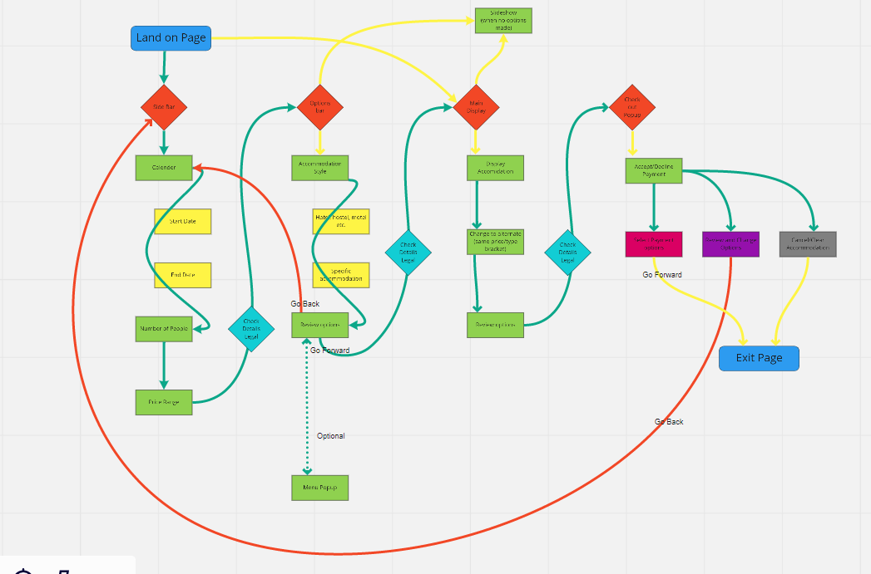

**UML Chart**

**https://miro.com/app/board/uXjVOckHT50=/?invite_link_id=850493650474**

**Conclusion/Justifications**

In this section I will conclude the project on Dark Skies Tekapo, comment on the timeline and make justification for choices I have made.

**Timeline:** The timeline I set at the start of this project has been immensely helpful. I have managed to mostly stick to my milestones, and having a guide that I can look at that maps out my progress has helped me to work out what areas to prioritise and what to come back to. This was especially helpful towards the end of the project where I had slated myself to finish quite a lot of coding in the final days. This led to dropping a word search function from the application as it was not a requirement for Tourism NZ, whilst having reactivity for use of the website on mobile phones was. One section of the timeline that took longer than expected was the coding of the application. I should have given myself another week for this and reduced the time for general research by a couple of days. This is a consideration for the future, as is having more time for bug checking and media queries. It has been difficult to predict how much time was needed for the coding aspect as much of what I used to code the application I learnt whilst making it.

**Justifications:**

Visual justifications: When making the moodboard I had wanted to make the website family friendly. As I progressed to making the hi fi, I leant more towards making the application geared towards families with young children- a market who look to find educational avenues in tourism. This was expressed visually by use of colourful space-orientated icons from www.flaticon.com , to give the impression of a child’s bedroom with glow-in-the-dark planetarium stickers. I was limited in my choice of fonts, the mian font (Proxima Nova) and the header font (pure Pakati) having been set by Tourism NZ’s style guide, but i was able to use a third font from Google fonts called Permanent Marker, which highlights the child friendly approach I took. I removed my original idea of having a slideshow of images when no card was selected, instead showing all available accommodation cards in a ‘small card’ format, from which they could be selected and enlarged. Overall, my visual design remained very similar to my hi fi design, the mobile version having to drop some elements (like icons) for lack of space as a reason.

Coding justifications: As time progressed I had to curtail some of the features I wanted on the website, and simplify others. I was originally going to have a reactive menu for customers to choose three meals a day- as it was a requirement for Tourism NZ to have a menu feature. This was simplified to having a set menu for each accommodation that customers could choose to have or forgo using a clickable modal. I was also planning on having more filtering options, as well as being able to click between the accommodation cards whilst they were open, I did not have enough time to do this. During the latter half of the coding experience I discovered easier ways to do some things I had already coded, which I had achieved in a round about fashion. I had the option to go back and change these with better methods (such as using select menus instead of hamburger menus) - but some of these I left as I had originally coded for variety and to show how I have developed better techniques over time. In the first half of the coding I relied too much on appending HTML with javascript, I have learnt some ways to lessen this as it takes up many lines of code. In future projects I will attempt to avoid appending as much as possible with these new techniques.

Bug justifications: I have done a large amount of debugging for my code. There are still a couple of persistent bugs I did not have time to completely figure out. This first bug is to do with my select button for filtering the page by the number of people staying in an accommodation. This select menu has to be clicked twice to function, I am unsure as to why this is- but as it does function and I had limited time I moved on from this. The second bug I have in my code is to do with my datepicker function. I found this the most difficult piece to code correctly, and was able to make it reactive to the accommodation selected, when a date is input into the start date section it automatically gets rid of dates in the end date section that go beyond the maximum nights that the specific accommodation allows. I tried to do a similar thing for the minimum nights that some accommodation also calls for, and was partially successful. I could get an error message to appear to warn the users they had inputted not enough nights to be over the minimum night stay count, but I have had a lot of difficulty in resetting the calendars after this, and for them not to allow wrong dates through if another accommodation is selected subsequently. I partially fixed this by having a condition that if the nights stayed was too short for a particular accommodation, the website would reset. Whilst I would rather just the dates to have reset, this is the compromise I have made within the time given by Tourism NZ.

**Conclusion**

Overall I am happy with the results from making this application for Tourism NZ. It has increased my knowledge of javascript by at least 4 fold, and there is a marked improvement in the coding I did towards the end compared to that at the start. I managed to achieve most of the milestones and goals set in the required time, an aspect of assignments I am usually not good at. In future assignments I need to make sure to have set more time for the coding aspect as this takes the most time. I also need to spend more time making the website reactive to different screen sizes, and make this more integral to my coding, rather than applying media queries afterwards. This meant that I only had desktop and mobile configurations, none for tablets as I did not have the time. Also, my mobile version looks much poorer than my desktop as it was quite rushed. Another feature I would like to have made is a ‘help’ popup for users to inform people on how to use the application, although I tried to make it as intuitive as possible I am not sure I entirely succeeded. I will keep these shortcomings in mind for my next project.